Laparoscopic Inguinal Hernia Repair - Elective

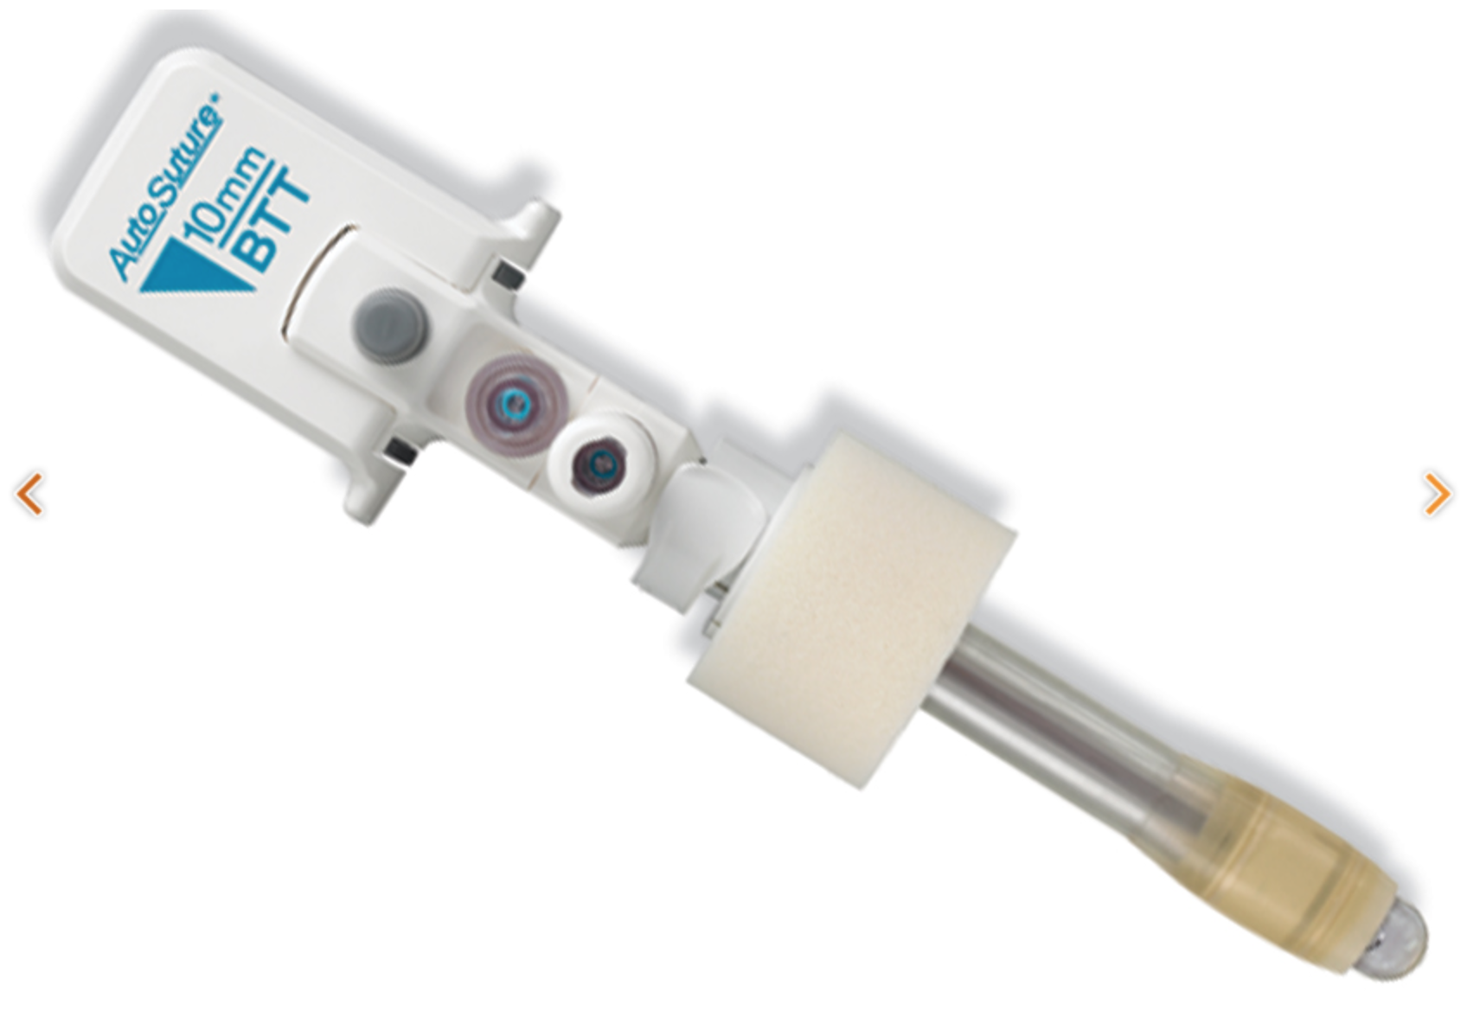
Gloves: 7 ½ Biogel

Patient Positioning:
Both arms tucked
Chloraprep from nipples to pubis
Foot pedal opposite of hernia
Tower at the feet

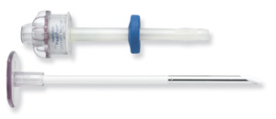
Local:
0.25% Marcaine w Epi

Trocars:
Veress needle in room unopened
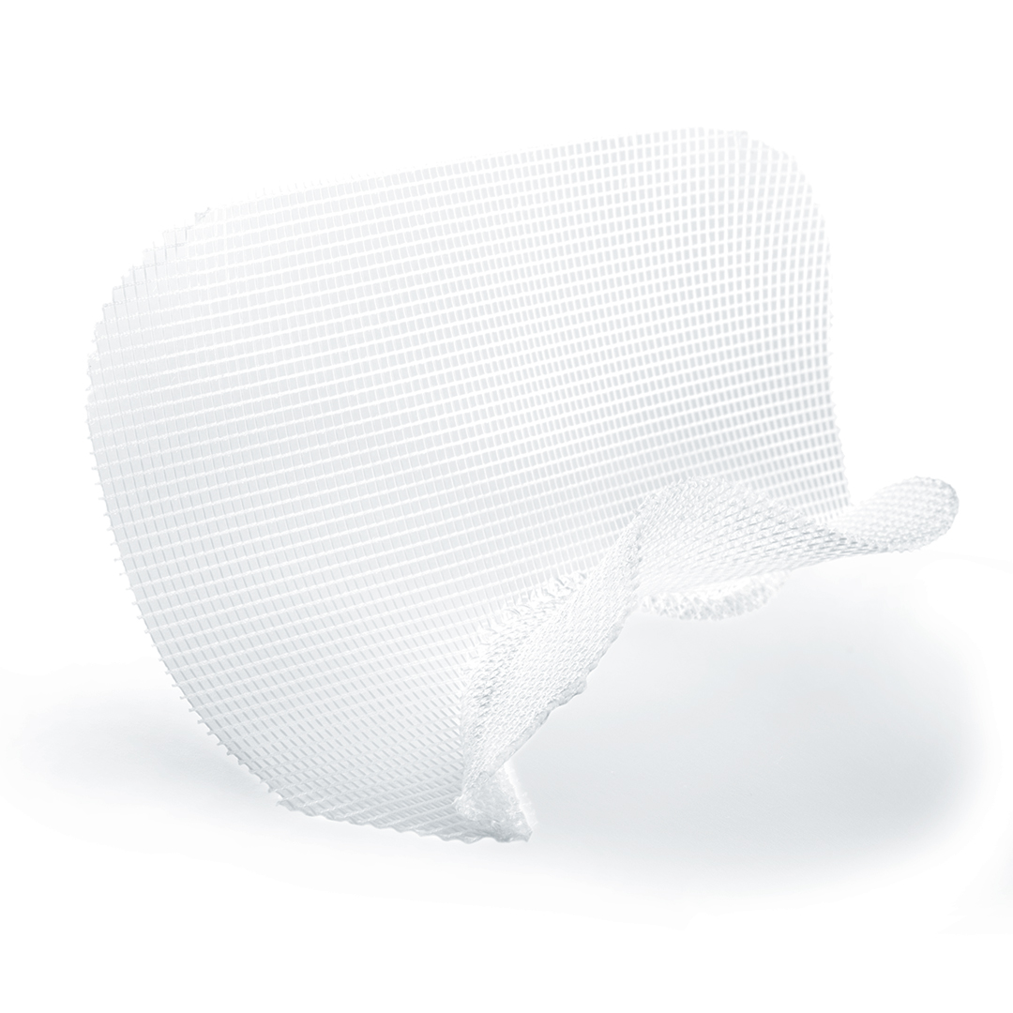
5mm Covidien locking trocar x2
Auto Suture 10mm balloon trocar

Instruments:
Covidien Parietex preformed mesh – verify correct side
(TECT1510AL or TECT1510AR)
10mm 0 degree laparoscope, 30 degree in room
S Shape x2
Platypus or dolphin nose x2
Laparoscopic Metzenbaum in room

Suture:
4-0 Monocryl x1 PS-2
0 Vicryl UR6

Dressing:
Dermabond or generic equivalent
Laparoscopic Cautery, no hand cautery

Available, Not Opened:
Suction/Irrigator in room unopened
Veress needle

